- Web Site Goal
The goal of the site is to be informative and accessible.

- Describe the goal of your web site in one or two sentences.
To be a method to teach, inform, get behind a communicate and access merchandise for volleyball

- What results do I want to see?
I want to see 7 working pages and a website that I could use in the future

- List the working title of each page on your web.
Home page
About
Community
Register
Lessons
Shop
Pricing

- What information do I need?
I need pricing for gear so I chose sport sites such as Dick’s sporting good, or Academy Sport for gear and pricing information. I can use the “Meetup App” for information with the communities here in Georgia, as it is a tool to help people gather and play. Using Youtuber “Elevate Yourself” as a credible source for videos. As for the rest I can use a site such as D-Bat to get a general feel for what I want for a site.

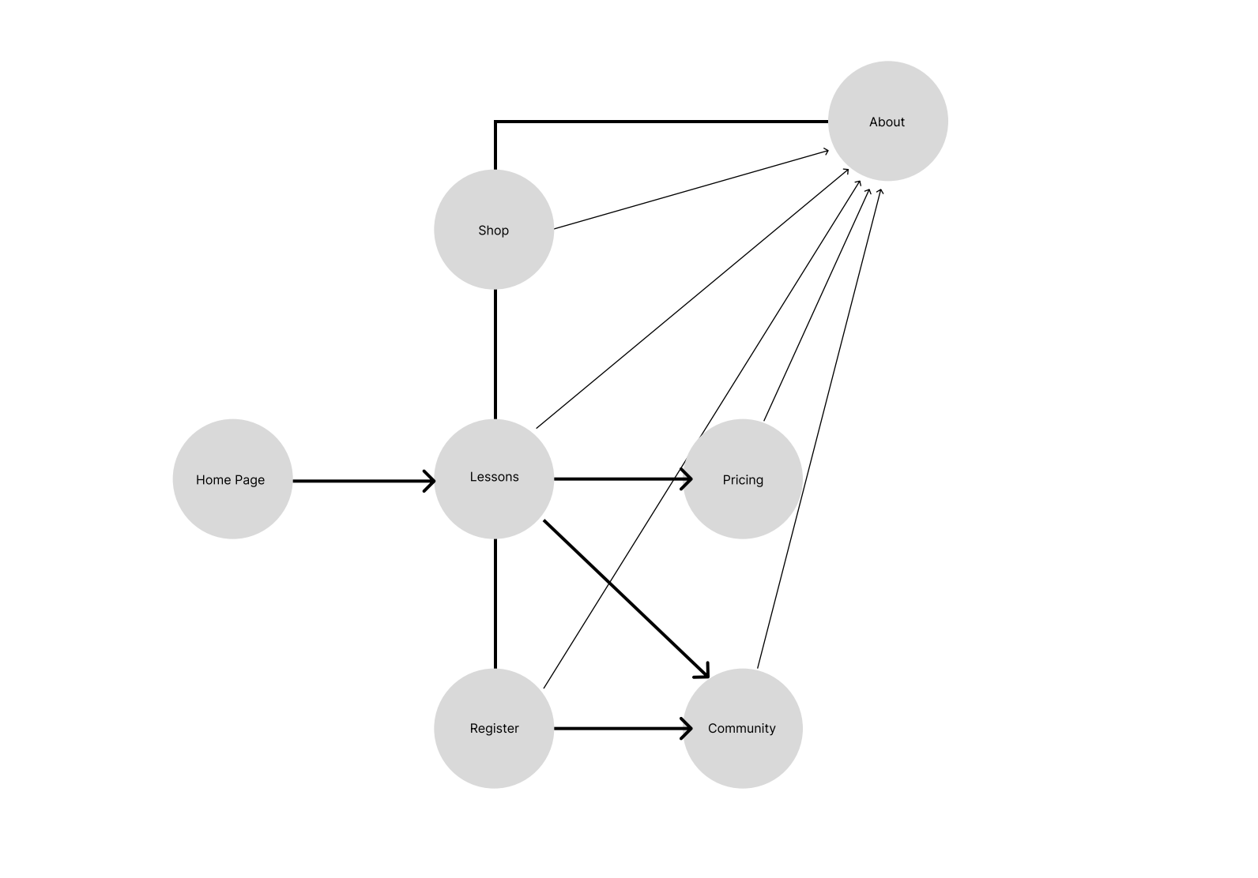
FlowChart

URL
https://rovidchavez.github.io/IT3203/

